**Walmart Data Analytics (E-Commerce Project )with Python**

**DS Vidya Dhanbad**

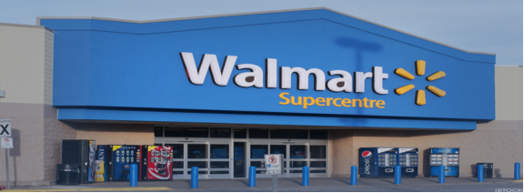

Walmart operates in both the retail and wholesale sectors. The business provides a range of goods and services at regular, affordable prices. It is an American multinational retail company and a global supermarket chain. Its headquarters are in Bentonville, Arkansas.

Walmart has been the top company on the Fortune Global 500 list for 11 consecutive years, including in 2024:

2024: Walmart is ranked number one on the Fortune Global 500 list with a revenue of $648.125 billion.

2023: Walmart's total revenue for the year was $611.3 billion.

2022: Walmart was the world's largest company by revenue, according to the Fortune Global 500 list.

Walmart is one of the most trustworthy retail stores and also a successful venture by Sam Walton. It has grown from its humble beginnings as a small retail business in Arkansas to thousands of stores across the US and overseas. Through innovation, the company is also building a seamless experience for people to purchase online and in stores at any time and location. Customers and communities throughout the world benefit from the opportunities it provides.

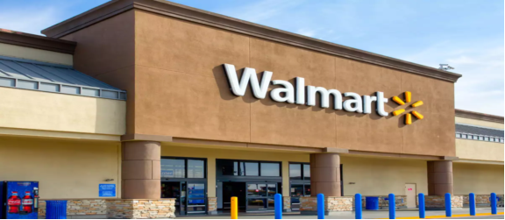

**Retail-Analysis-with-Walmart-Data-Project**

The aim of this project is enable category managers of Walmart to check the weekly and monthly sales of the departments. Analysis includes the effect of markdowns on the sales and the extent of effect on the sales by fuel prices, temperature, unemployment, CPI etc.

The decision makers of Walmart should be able to analyze the effect of various factors affecting the sales of the products in their stores.

**Data Understanding**

There are sales data available for 45 stores of Walmart in Kaggle. This is the data that covers sales from 2010-02-05 to 2012-11-01.

The data contains these features:

Store - the store number

Date - the week of sales

Weekly_Sales - sales for the given store

Holiday_Flag - whether the week is a special holiday week 1 – Holiday week 0 – Non-holiday week

Temperature - Temperature on the day of sale

Fuel_Price - Cost of fuel in the region

CPI – Prevailing consumer price index

Unemployment - Prevailing unemployment rate.

**📈Analysis to be Performed:**

**Do retail analysis with Walmart data and answer the following questions:**

**1) Which stores have maximum and sales?**

**2) Which store has maximum standard deviation i.e., the sales vary a lot?. Also, find out the coefficient of mean to standard deviation.**

**3) Which store/s has good quarterly growth rate in Q3’2012?**

**4) Find out holidays which have higher sales than the mean sales in non-holiday season for all stores together.**

**5) Provide a monthly and semester view of sales in units and give insights.**

------------------------------------Thank You-----------------------------------------